**Texas Instruments Capital Equipment**

**Shipping Process**



Printed specifications are not controlled documents. Verify revision before using

TI Information - Selective Disclosure

1. Scope

This specification defines the minimum general requirements for the preparation, collection, and   
 delivery of Capital Equipment that will be shipped to any Texas Instrument Incorporated facility.

1. Reference

2.1 Texas Instruments Equipment Crating (EDGE 6598929)  
2.2 Texas Instruments Supplier Packing and Labeling Manual for Global Shipping (EDGE 6512960)

1. Definition
   1. Capital Equipment – An asset used by any Texas Instruments Incorporated facility to produce other commodities. In the PO, Capital Equipment will be categorized as “Z”.
   2. Shipper – An individual who make the cargo ready to be shipped. For PO type Capital Equipment shipment, TI Equipment supplier will be the shipper, while for plant to plant shipment, TI Category Logistics personnel (Shipping) is the shipper.
   3. Crating & Rigging Supplier – provides the service of crating, packing, uncrating, moving the  
      equipment to any TI facility.
   4. PO – Purchase Order
   5. Incoterms – are set of rules which define the responsibilities of sellers and buyers for the delivery of goods under sales contracts.
   6. Hand-off Point - the location where the shipment was handed over from one party to another  
      party.
   7. Cargo Inspection Sign-off Report – report that contains the information of the Capital Equipment shipment such as PO number, invoice number, incoterm, shipment pickup date, shock watch and tilt indicator’s serial number. This report must be signed and acknowledge by the party who receives the cargo.
   8. Template for Photos – template with standard format that allows forwarder to attach photos of Capital Equipment taken during hand-off.
   9. Crating Compliance Checklist – a checklist that requires shipper to complete and affix to each tool crate shipped to ensure packing and crating of the Capital Equipment fulfill the requirements in the TI Crating Edge Spec 6598929.

3.10 Shock Watch indicator – indicators mount to the exterior of the packaging of a shipment and

Visually alerts person involved in the handling of the package that additional care is required. If

mishandling occurs during the shipment and handling cycle, the shock watch indicator serves

as a permanent record of mishandling.

3.11 Tilt Indicator - detect unacceptable tilting on goods that must remain upright. When these   
 indicators are used, the product cannot be tipped without indisputable evidence of mishandling.

3.12 Digital Tracking Device – Digital device that mounts to the exterior of packaging of a shipment and automatically reports on cargo handling including but not limited to GPS location, shock, temperature, and humidity.

3.13 Estimate Time of Departure – the expected start time of a particular journey.

3.14 Estimate Time of Arrival – the time when a ship, vehicle, aircraft, cargo, emergency service or   
 person is expected to arrive at a certain place.

3.15 Full Container Load (FCL) - an ocean shipment in which cargo occupies a full container.

1. Responsibility
   1. Shipper - TI Equipment Supplier, who sells the Capital Equipment and make it ready to be shipped to any Texas Instruments Incorporated facility, will be the responsible to packed and crated the Equipment according to the requirements in Texas Instruments Equipment Crating (EDGE 6598929) and to comply with requirements contained in this manual. The individual must affix crating compliance checklist to each tool crate shipped. Any Equipment that is required deviation from requirements contained in this manual, shipper must specify the reason and get written authorization from TI Category Logistics personnel (Transportation).
   2. Shipper – TI Category Logistics personnel (Shipping), who prepared the Capital Equipment ready to be shipped to any TI facility will be responsible to ensure that the Cargo Inspection Sign-off report is completed without information discrepancy and submit to forwarder during shipment pick-up.
   3. TI Crating and Rigging Supplier – provides the service of crating, packing, uncrating and moving the Capital Equipment to any TI facility is responsible to ensure that the Capital Equipment is packed and crated according to TI’s Equipment Crating Edge Spec 6598929 and to comply with requirements of this specification. Crating and Rigging Supplier (Shipper) must affix crating compliance checklist to each tool crate shipped.

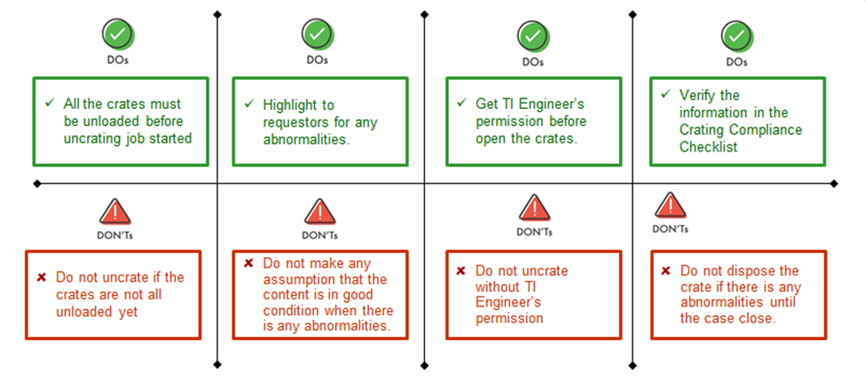

Fig 1. Dos and Don’ts during shipment arrival – TI Crating and Rigging Suppliers

* 1. TI Forwarder – provides the service of delivering the Capital Equipment to any TI facility, is responsible to comply with the requirements contained in this specification. The individual is responsible to ensure cargo is in good condition, the packing of the cargo is suitable for the transport mode, and the information in the Cargo Inspection Sign off Report tallies with physical cargo received during shipment handoff.

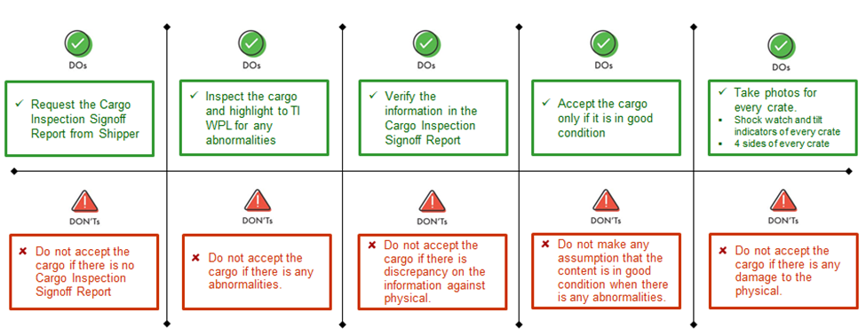

Fig 2. Do’s and Don’ts during shipment hand-off – TI Forwarder

* 1. TI Category Procurement personnel (Buyers) – to monitor shipper (TI Equipment shipper) and TI’s crating and rigging supplier’s compliance to TI’s Edge Spec 6598929 and the requirements contained in the specification. Ensure that compliance checklist is affixed to each tool crate shipment.

4.6 TI Category Logistic personnel (Transportation) = to monitor the forwarder’s compliance to TI’s   
 Equipment Crating Spec 6598929 and the requirements contained in this specification. The   
 individual is to conduct random sampling audit to ensure cargo received meeting the requirements   
 contains in this manual. If there is any discrepancy between the Inspection Sign off report, and no  
 cargo inspection sign off report signed or submitted to TI Category Logistic personnel (Receiving)   
 by forwarder, the transportation manager shall investigate, close the gap, and increase the audit   
 frequency. TI Category Logistics personnel (Transportation) is to determine and provide a written   
 authorization prior to the shipment for any Capital Equipment that is required deviation from   
 requirements contained in this manual.

4.7 TI Category Logistics personnel (Receiving) – It will be the responsibility of receiving personnel to  
 ensure that cargo is in good condition, and the information in the Cargo Inspection Sign off Report   
 tallies with physical cargo received upon shipment arrival.

4.8 TI Routing center – to comply with the requirements contained in this specification. TI’s Routing  
 Center shall coordinate and make arrangement on the transportation. TI Routing Center must   
 inform forwarder if there is written authorization from TI’s Category Logistic personnel for the   
 Capital Equipment that is required deviation from the requirements contained in this manual from   
 TI’s Category Logistics personnel (transportation).

4.9 Application – Adherence to the requirement of this specification is necessary to avoid conflict   
 among shipper, forwarder, and consignee when shipment is damaged upon arrival at TI facility.  
 Special shipping specification called out on a request will take precedence over this specification  
 if they are in conflict as being communicated and agreed by TI Category Logistics personnel   
 (transportation).

4.10 Communication – All suppliers and forwarder questions, communications, and exception request  
 are to be coordinated through TI Category Logistics personnel (Transportation).  
 TI’s Routing center general contact information  
 Email : [texasinstruments@pegasuslogistics.com](mailto:texasinstruments@pegasuslogistics.com)  
 Phone: +1-800 854 3364  
 TI Global Transportation  
 WPL Transportation email distribution list : [custrans@list.ti.com](mailto:custrans@list.ti.com)

4.11 Compliance – compliance to the TI Capital Equipment shipping process requirements contained   
 in this manual will be enforced as a condition of purchase of Equipment or service. TI reserves the  
 right to:

4.11.1 Reject and return any shipments that are not complied with the requirement as defined by   
 this manual.

4.11.2 Charge the supplier or forwarder for the costs of labor and materials for any damage   
 recovery of the Equipment resulting from non-compliance with this manual.  
 4.11.3 Remove from its list of approved supplier sources any supplier that, after notice, repeatedly   
 fails to comply with Texas Instruments Inc. packing requirements.   
 4.11.4 Any supplier and forwarder requiring deviation from requirements contained in this   
 specification must receive written authorization from the TI Category Logistics personnel   
 (Transportation) prior to shipment collection.

1. Shipping Requirements and Procedures

These are the minimum shipping requirements and procedures for high value semiconductor electronic Capital Equipment and/or instruments.

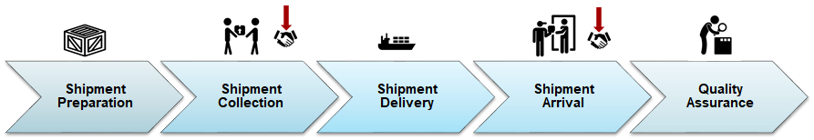

Fig 3. (Please refer to the Reference 4 for full details of the TI Capital Equipment Shipping Process Flow)

5.1 Shipment Preparation 5.1.1 TI Category Procurement personnel (buyers) must ensure the incoterms in the PO   
 states clearly according to the format below:

Incoterm + handoff point

(Ex. FCA buyer forwarder or FCA port of export or Ex-work Disco)

5.1.2 Shipper (TI Equipment Supplier) or TI Crating & Rigging supplier shall perform   
 crating and packing according to TI’s Edge Spec 6598929.  
 5.1.3 Shipper (TI Equipment Supplier) or TI Crating & Rigging supplier shall complete   
 the Crating Compliance Checklist. This document is to be printed and affixed to each   
 tool crate shipped.  
 5.1.4 Shipper (TI Equipment Supplier) or TI Crating & Rigging supplier shall ensure 2   
 shock watch indicators (15G & 25G) and 1 tilt indicators are affixed to each tool crate   
 shipped.

5.1.5 Shipper (TI Equipment Supplier) or TI Crating & Rigging supplier shall ensure  
 shock watch and tilt indicators have serial number on the physical.

5.1.6 Shipper (TI Equipment Supplier) or TI Crating & Rigging supplier shall ensure  
 digital tracking device are affixed to the main body of each tool shipped in accordance

With TI’s Edge Spec 6598929

5.1.7 Shipper (TI Equipment Supplier) shall contact TI’s Routing Center for the   
 transportation arrangement once the shipment is ready.  
 5.1.8 Any supplier requiring deviation from requirements contained in this manual must   
 receive written authorization from the TI Category Logistics personnel (Transportation)   
 prior to shipment collection.  
 5.1.9 TI Routing Center shall coordinate, make transportation arrangement, and provide  
 forwarder’s details.

5.1.10 TI Routing Center must inform forwarder if there is written authorization from TI   
 Category Logistics personnel (Transportation) for the Equipment that is required   
 deviation from requirements contained in this manual from TI Category Logistics   
 personnel (Transportation).

5.1.11 TI Routing center shall ensure Capital Equipment by Ocean freight is proceeded  
 with Full Container Load (FCL).

5.2 Shipment Hand-off  
 5.2.1 Shipper (TI Equipment Supplier) or Shipper – TI Category Logistics personnel   
 (Shipping) shall complete the Cargo Inspection Sign off Report and hand it over to TI   
 forwarder during shipment handoff.

5.2.2 Shipper must fill up the Purchase Order No, Invoice No, Shipment Pickup Date, and Incoterm.

5.2.3 Shipper must fill up the Crate No. and shock watches, tilt indicator serial number, and Tracking Device fields

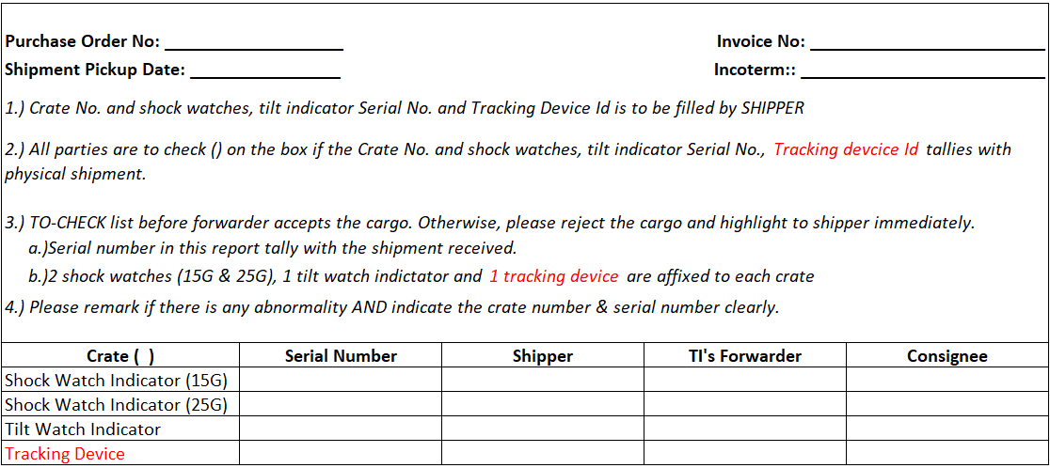

Fig 4. (Example of Cargo Inspection Sign off Report)

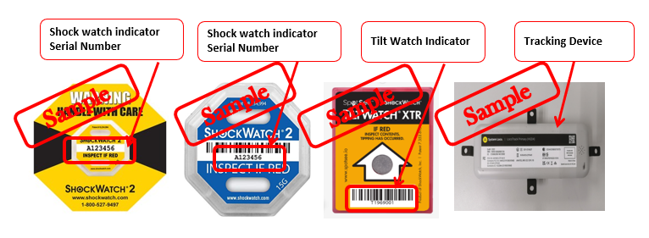

Fig 5. (Example of shock watches, tilt indicator Serial No. and tracking device)

5.2.4 TI Forwarder shall verify the information in the Cargo Inspection Sign off Report   
 provided by shipper against physical shipments received.  
 5.2.5 TI Forwarder shall ensure that 2 shock watch indicators (15G & 25G) and 1 tilt   
 indicator are affixed to each crate unless there is written authorization from TI  
 Category Logistics personnel (Transportation). Additionally TI Forwarder shall

ensure that a tracking device has been attached to the main body crate.  
 5.2.6 TI Forwarder shall perform inspection on the shipment condition and bring   
 attention to TI Category Logistics personnel (Transportation) and TI’s Routing   
 Center if there is any abnormality.

5.2.7 TI Forwarder must sign on the Cargo Inspection Sign off report submitted by  
 Shipper (TI Equipment shipper) or Shipper – TI Category Logistics personnel  
 (Shipping), acknowledge that the shipment condition that is suitable and safe for  
 the transport mode.   
 5.2.8 TI Forwarder must take photos of the shipment and send it to TI Category Logistics   
 personnel (Transportation) using Template for Photos within 3 days after the  
 shipment handoff. Photos must consist of 4 angles of each crate and clear photo   
 on shock watch and tilt indicator affixed to each tool crate shipped (the color of the  
 shock watch and tilt indicator must be visible to the naked eye). At least one photo

Must be taken showing tracking device is affixed to the main body crate.

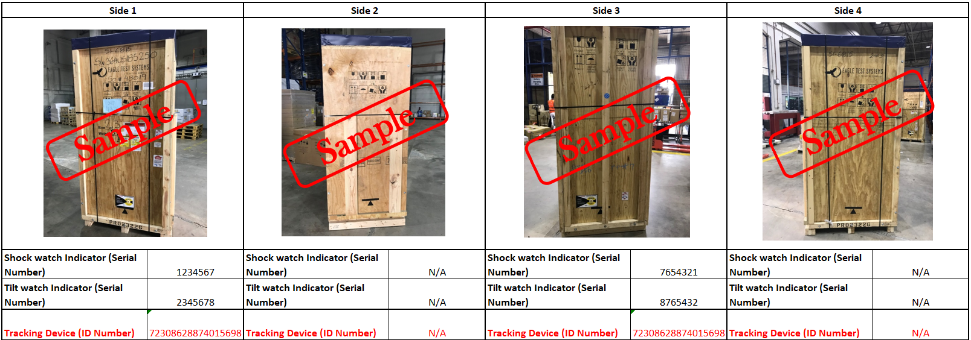

Fig 6. (Example of 4 angles of each crate)

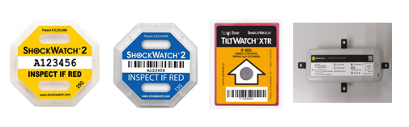

Fig 7. Example of clear photo on shock watch, tilt indicator and tracking device - the color

of the shock watch, tilt indicator and tracking device must be visible to the naked eye.

5.2.9 TI Category Logistics personnel (Transportation) shall ensure photos taken and sent by  
 forwarder according to the requirements in this manual within 3 days after shipment   
 received by forwarder.

5.2.10 TI Forwarder must reject and return the shipment to supplier (shipper) during shipment   
 handoff and bring attention to TI Category Logistics personnel (Transportation) and TI   
 Routing Center ASAP in case any of the circumstances below:

a. Cargo Inspection checklist is not provided by supplier (shipper).  
 b. Does not meet the requirement of 2 shock watch (15G & 25G) and 1 tilt indicators.

c. Does not meet the requirement of tracking device attached to main body crate.  
 d. Shipment was crushed, dented, broken, leaking, or molded.

e. Discrepancy between physical and information in the inspection checklist.

f. Packing and crating of the shipment is not suitable for the transport mode, which

might cause the tools damage.

g. Packing and crating of the shipment is in unsafe for the transport mode, which might   
 cause the tools damage.

5.2.11 Quality Inspection  
 5.2.11.1 Crating and rigging supplier shall hand over the Crating Compliance  
 checklist to TI Category Logistics personnel (Receiving) after the verification.  
 5.2.11.2 TI Category Logistics personnel (Receiving) shall archive the Cargo   
 Inspection Sign off Report, and Crating compliance checklist together with   
 shipping documents.  
 5.2.11.3 TI Category Logistics personnel (Transportation) shall conduct random  
 sampling audit to ensure cargo received meeting the requirements contains in   
 this manual. If there is any discrepancy between the Inspection Sign off report,   
 and no cargo inspection sign off report signed or submitted to TI Category Logistic   
 personnel (Receiving) by forwarder, TI Category Logistics personnel   
 (Transportation) shall investigate, close the gap, and increase the audit frequency.

 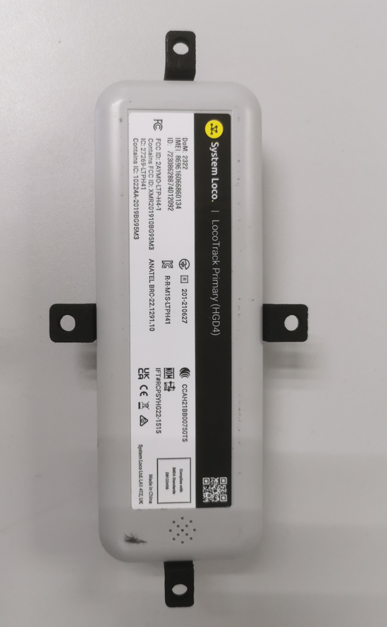

Fig 8. (Example of shock watches (15G & 25G), tilt indicator and tracking devices)

* + 1. Shipment in Transit

1. TI Forwarder must notify TI Category Logistics personnel (Transportation) and TI’s Routing Center on the estimate time of departure and estimate time of arrival, including any delays of changes of schedule.
2. TI Forwarder must notify TI Category Logistics personnel (Transportation) 3 days ahead of shipment arrival at port.
   * 1. Shipment Arrival  
        a. TI Forwarder must submit the Cargo Inspection Sign off Report to TI Category  
         Logistics personnel (Receiving) upon shipment arrival at Texas Instrument   
         Incorporated facility.
3. TI Category Logistics personnel (Receiving) shall ensure the Cargo Inspection Sign off report submitted by Forwarder and bring attention to TI Category Logistics personnel (Transportation) if there is no Cargo Inspection Sign off report.
4. TI Category Logistics personnel (Receiving) shall verify the information in the Cargo Inspection Sign off report against physical shipment received and inspect the shipment condition upon shipment arrival at Texas Instrument Incorporated facility with the present of end user/requestor.
5. TI Category Logistics personnel (Receiving) shall highlight to TI Category Logistics personnel (Transportation) if there is any abnormality.
6. TI Category Logistics personnel (Receiving) shall sign on the Cargo Inspection Sign off report submitted by forwarder to acknowledge the shipment condition and accept the shipment.
7. TI Category Logistics personnel (Receiving) shall get acknowledgement from the end user/requestor that the shipment is received in good condition.
8. Crating & rigging supplier must get approval from end user/requestor before uncrating or moving the cargo.
9. Crating and rigging supplier shall verify the information in the Crating Compliance Checklist against physical shipment received and bring attention to TI Category Procurement personnel (buyers) and TI Category Logistics personnel (Transportation) if there is any discrepancy. Crating and Rigging shall remove digital tracking device and hand it to TI Category Logistics personnel to dismantling crate.

Attachment 1. Cargo Inspection Sign Off Report

*This document can be downloaded at* [*https://wpl.ext.ti.com/itc/itc.htm*](https://wpl.ext.ti.com/itc/itc.htm)

|  |  |  |  |  |
| --- | --- | --- | --- | --- |
|  | | | | |
| **Purchase Order No: _____________________ Invoice No: ___________________**  **Shipment Pick Up Date __________________ Incoterm: _____________________** | | | | |
|  | |  | | |
|  | |  | | |
| ***1.) Crate No. and shock watches, tilt indicator Serial No. and Tracking Device Id is to be filled by SHIPPER*** | | | | |
| ***2.) All parties are to check () on the box if the Crate No. and shock watches, tilt indicator Serial No., Tracking device Id tallies with physical shipment.*** | | | | |
| ***3.) TO-CHECK list before forwarder accepts the cargo. Otherwise, please reject the cargo and highlight to shipper immediately.*** | | | | |
| ***a.) Serial number in this report tally with the shipment received.*** | | | | |
| ***b.)2 shock watches (15G & 25G), 1 tilt watch indicator and 1 tracking device are affixed to each crate*** | | | | |
| ***4.) Please remark if there is any abnormality AND indicate the crate number & serial number clearly.*** | | | | |
|  | | | | |
| **Crate ( )** | **Serial Number** | **Shipper** | **TI's Forwarder** | **Consignee** |
| **Shock Watch Indicator (15G)** |  |  |  |  |
| **Shock Watch Indicator (25G)** |  |  |  |  |
| **Tilt Watch Indicator** |  |  |  |  |
| **Tracking Device** |  |  |  |  |
| **Crate ( )** | **Serial Number** | **Shipper** | **TI's Forwarder** | **Consignee** |
| **Shock Watch Indicator (15G)** |  |  |  |  |
| **Shock Watch Indicator (25G)** |  |  |  |  |
| **Tilt Watch Indicator** |  |  |  |  |
| **Tracking Device** |  |  |  |  |
| **Crate ( )** | **Serial Number** | **Shipper** | **TI's Forwarder** | **Consignee** |
| **Shock Watch Indicator (15G)** |  |  |  |  |
| **Shock Watch Indicator (25G)** |  |  |  |  |
| **Tilt Watch Indicator** |  |  |  |  |
| **Tracking Device** |  |  |  |  |
| **Crate ( )** | **Serial Number** | **Shipper** | **TI's Forwarder** | **Consignee** |
| **Shock Watch Indicator (15G)** |  |  |  |  |
| **Shock Watch Indicator (25G)** |  |  |  |  |
| **Tilt Watch Indicator** |  |  |  |  |
| **Tracking Device** |  |  |  |  |
| **Crate ( )** | **Serial Number** | **Shipper** | **TI's Forwarder** | **Consignee** |
| **Shock Watch Indicator (15G)** |  |  |  |  |
| **Shock Watch Indicator (25G)** |  |  |  |  |
| **Tilt Watch Indicator** |  |  |  |  |
| **Tracking Device** |  |  |  |  |
| **Crate ( )** | **Serial Number** | **Shipper** | **TI's Forwarder** | **Consignee** |
| **Shock Watch Indicator (15G)** |  |  |  |  |
| **Shock Watch Indicator (25G)** |  |  |  |  |
| **Tilt Watch Indicator** |  |  |  |  |
| **Tracking Device** |  |  |  |  |
|  | | | | |
| **Remarks (By Shipper): _______________________________________________________________________________** | | | | |
| **Remarks (By Forwarder): _____________________________________________________________________________** | | | | |
| **Remarks (By Consignee): _____________________________________________________________________________** | | | | |
|  | | | | |
| **BY SIGNING TEXAS INSTRUMENTS CARGO INSPECTION & SIGN OFF REPRT, TI NOMINATED LOGISTICS PROVIDER HAS ACKNOWLEDGE THE FREIGHT CONDITION AND RESPONSIBLE FOR ANY DAMAGES FROM THE HANDOFF POINT UNTIL FINAL DESTINATIONBASED ON THE** | | | | |
|  | | | | |
| ***Shipper TI’s Forwarder Consignee*** | | | | |
|  | | | | |
| --------------------------------------- -------------------------------------- ----------------------------------- | | | | |
| Name: Name: Name: | | | | |
| Company: Company: Company: | | | | |
| Date: Date: Date: | | | | |
|  | | | | |

*This document can be downloaded at* [*https://wpl.ext.ti.com/itc/itc.htm*](https://wpl.ext.ti.com/itc/itc.htm)



Attachment 2. Crating Compliance Checklist

*This document can be downloaded at* [*https://wpl.ext.ti.com/itc/itc.htm*](https://wpl.ext.ti.com/itc/itc.htm)

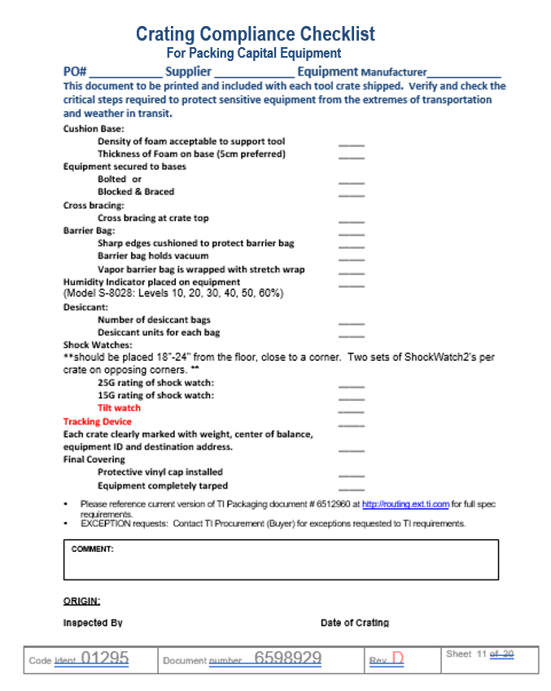

Attachment 3. Capital Equipment Shipping Process Flow

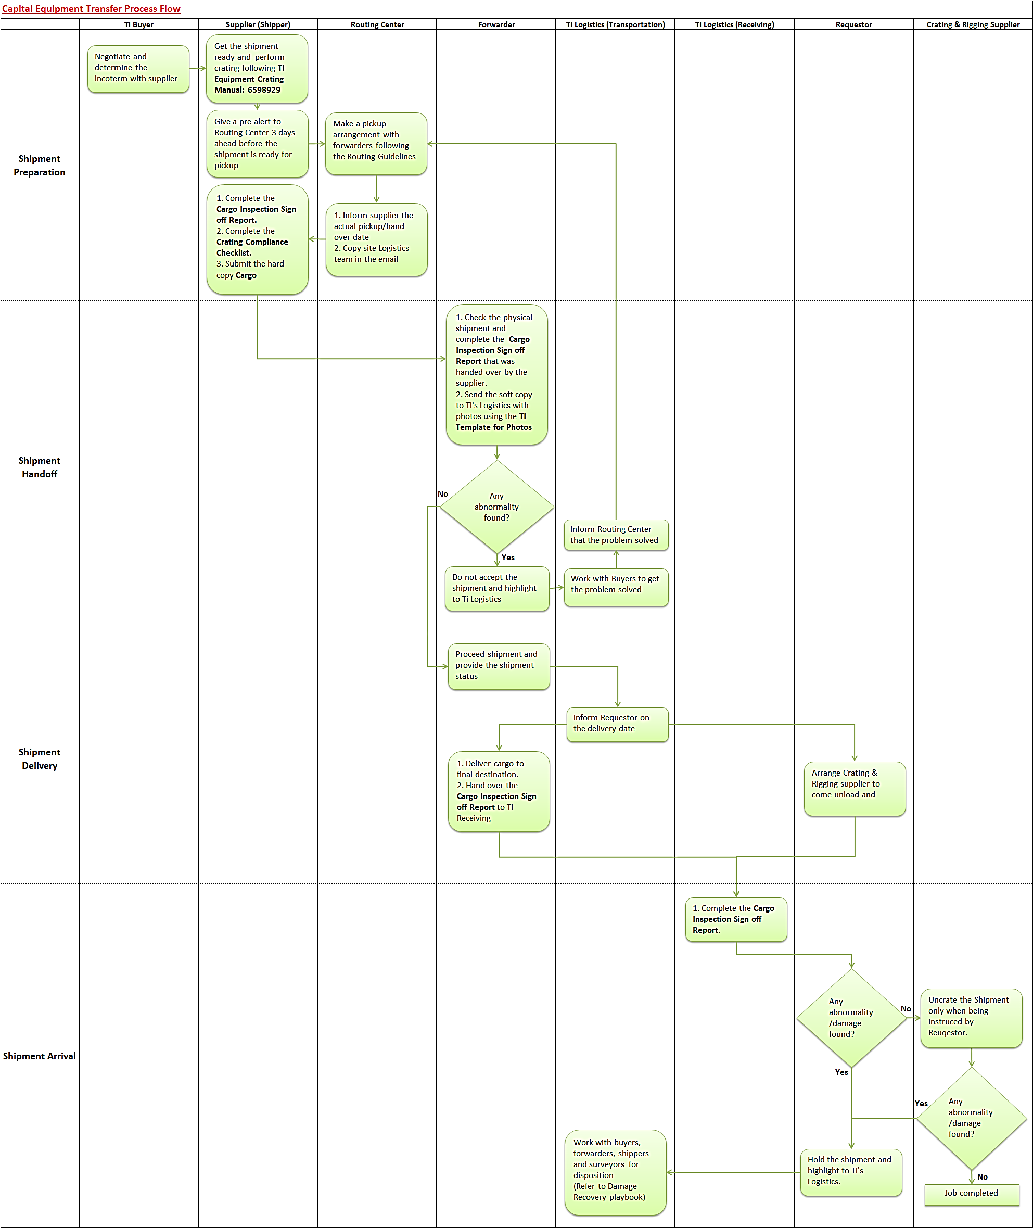

|  |  |
| --- | --- |
| **REV** | DESCRIPTION |
| A | ECR #2181066, 05/03/19, V. Orpilla, H. Klonis; Formal release. |
| B | ECR #2208155, 04/05/24, V. Orpilla, M. Castillo; 1) Added digitalTracking Device requirement |