Allow Abstract Dates in Custom Reporting
- Log on to http://augustus.iqnavigator.com
- Click on reports tab
- Click on the custom reports sub menu link
- Create, clone, or modify a custom report.
- On the screen to enter in report parameters, choose a Date parameter (i.e. date submitted for approval, etc.)
- Under “Operator” choose “for a period”
- Under “Values” select ‘Days’, ‘Months’, ‘Quarters’, ‘Weeks’, or ‘Years’
‘Current’: select to run the report for the current period (if applicable)
‘Last’ : enter the number of prior periods you want to pull (if applicable)
‘Next’: enter the number of future periods you want to pull (if applicable)
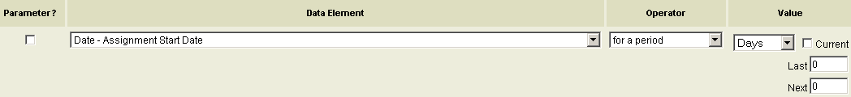

- Click the ‘next’ button
- Click the ‘submit’ or ‘save and submit’ button

